Directions: The goal of the following problems is to help challenge and deepen your understanding of the current topic. Don’t assume that you will know how to answer each and every question. You will work with at least two other students in the class to try and find solutions and write arguments for each of the following questions. Be sure that you question your classmates’ reasoning. If you don’t understand how they are getting something you should ASK THEM TO EXPLAIN! Being able to defend your reasoning is important and so you are actually helping them by asking them to explain.

Challenge Questions

- Answer the following limit questions showing full justification.

- Create three limits that all have the form of but produce the answers of , 0, and.

- Kyle is trying to answer the following questions and presents the following work to his professor. Why is Kyle’s work incorrect or insufficient to justify his answer?
- .

- .

- Evaluate the limit providing full justification.

- Determine the horizontal and vertical asymptotes to

- Determine the horizontal and vertical asymptotes to .

Recall the limit laws that we discussed in class.
Theorem: Suppose that c is a constant, n is a positive integer and the limits and exist. Then,

- TRUE or FALSE: If neither nor exists, then must not exist. If the statement is true provide a justification demonstrating that it is true. If the statement is false, provide a counter-example that shows the statement is false.

- TRUE or FALSE: If does not exist then it must be the case that either or do not exist. If the statement is true provide a justification demonstrating that it is true. If the statement is false, provide a counter-example that shows the statement is false.

Now we turn to some more atypical questions to challenge or understanding of the topics of this chapter thus far.

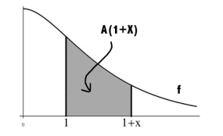
- The function f is continuous and decreasing on . Define to be the area from 1 to under the graph of f and above the x-axis (as shown in the picture below).

Compute . Hint:
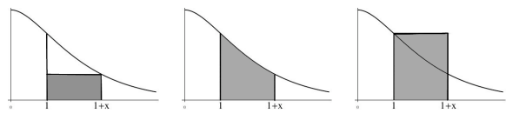

- Is there a value of a such that exists?

